Student table

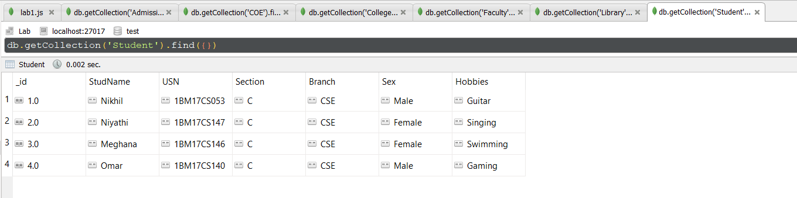

Admission Table

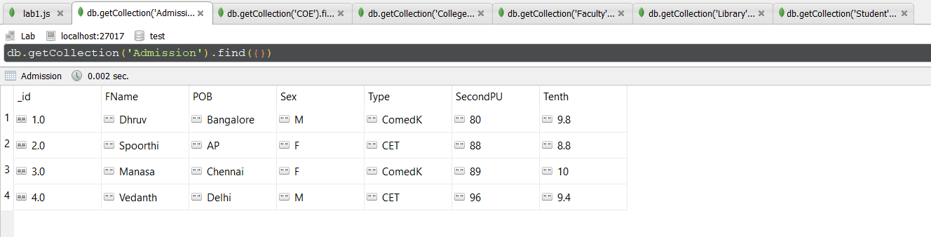

COE Table

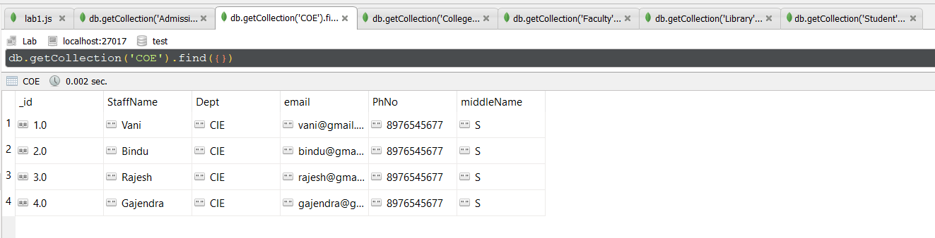

College Festival Table

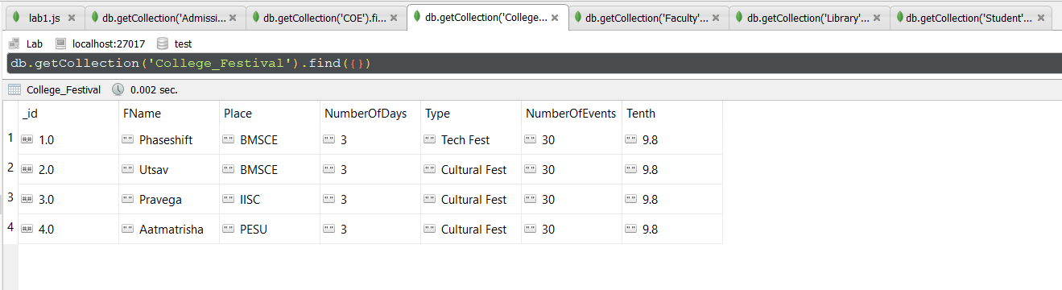

Faculty Table

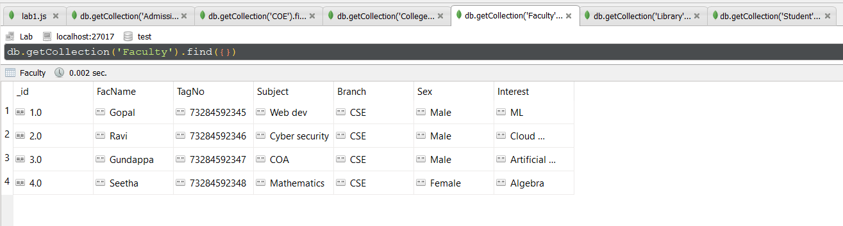

Library Table

